# Germany: Part One

What an amazing week I had!! Germany has a LOT more fall foliage than I've ever seen in Italy, so I've been trying to commit all the vivid colors into my permanent memory bank. I got to hang out with my granddaughter Avery; I caught up on life with my good friend Marnie and her family; I had the privilege of visiting THREE of my ancestral hometowns; and I saw beautiful autumn landscapes everywhere I went.

*Note: Sorry for the lateness of this post. I had 2 big trips back-to-back and then my laptop pooped out for a bit, and I couldn't use it!

There's a lot to cover, so the best way to organize everything is to share everything in a basic chronological order, day by day.

Monday, October 6th:

I rode the shuttle bus from Scott's base (Del Din) over to the Venice Airport. Sadly, it takes an extra hour just to get from the one base to the next because the driver has to stop in multiple locations at each one - and then he'll sit there for a solid 10 minutes before moving on to the next pickup spot. But this was the most convenient way to get me to the airport during the work week, so I was "happy" to absorb any inconveniences.

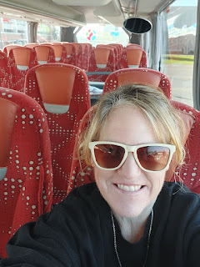

My flight was delayed so I ended up sitting around for an extra while at the Venice Airport . . . I had packed my own sandwich from home, along with some sliced peaches, so I found a seat near my gate and hung out there. Eventually, our plane was ready to depart and the flight was relatively short, which was nice. Only about 1 hour and 20 minutes.

As we prepared to land in Frankfurt, and during the

actual descent

where we could see the runway below us, all of a sudden - the pilot pulled the throttle and we shot right back up into the sky. One of the flight attendants announced that everything was okay and that the pilot would explain more in just a few minutes. His remarks were brief when he told us that they had spotted a plane that was not entirely clear of the runway . . . and that we now needed to circle all the way back around to try landing a second time, which would add another 10 minutes to our already delayed flight. I was not too worried, since I just needed a rental car and my situation would be in my own hands from that point on. But there were several people seated around me who would be missing their connecting flights, including several who were heading back to the U.S. I felt bad for them.

Everything took much longer than all of my previous flights in and out of Frankfurt. I walked a mile or two on my way to the baggage claim, stopping to use the bathroom on the way, and I still had to wait another 30 minutes or more for my suitcase to arrive on the carousel.

Then I walked another mile or more to get to the rental car facility. I was not prepared for the amount of people standing around waiting . . . I found a kiosk near the EuropCar line where I could log my name into the queue. Good thing I had already reserved a car in advance because I jumped to #5 in the priority line. There were 25 additional people in the other queue, who did not have a reservation . . . There was one man taking the priority customers and one man helping everyone else, just one at a time.

Over an hour later, I had the key in my hand for a VW Polo, a slightly smaller class of car than what I had reserved - but also cheaper. They were completely out of the next higher class of cars, and they gave me the choice to wait a little bit if I wanted to. Um no thanks, ha ha. I was already way behind schedule.

After a few wrong turns just to get out of the Airport, I was finally on my way south to Nanzdeitschweiler, where my friend Marnie Parker lives. (Pronounced like nonz-DYTCH-viler)

During the 1.5 hour drive, I kind of did my own thing with the speed limit (which is typically 10% over), but I learned some important things by the next day.

~ In Germany, the speed limit is the speed LIMIT. Sometimes people get fined for going just one mile over the limit. Hopefully I won't be getting a ticket in the mail in the near future . . .

~ The speeds fluctuate all the time and it's up to you to really pay attention. You can go from 100 km/hr to 130 to 80 to 100 in a very short stretch.

~ With the newer model of car, it had a snazzy adaptive feature with the cruise control. I would set it for 130 km/hr, but whenever it detected a lower speed limit it would automatically slow down the car. Sometimes it almost made me jump because the slowdown was so sudden. Interestingly, it would detect the lower speed limit WAY in advance, slowing me all the way down by the time we actually hit the new speed limit sign. But when the speed limit signs increased, the car would wait until a solid 1-2 seconds PAST the sign before speeding up . . . goodness.

~ My FAVORITE thing that I learned from both the Parkers and Kylie is that there is also a special speed limit sign that means you can go whatever speed you want!!! I had seen it several times on my way down from Frankfurt, but I didn't know what it meant. Once I knew, I had lots of fun for the rest of the week!! The fastest I ever went on the no-limit stretches was 168 km/hr. ( = 104 mph), but that was only briefly. Most of the time, I would cruise along at roughly 155 km/hr. ( = 96 mph).

I had a nice supper waiting for me that Marnie had made . . . a delicious Chicken Taco Soup.

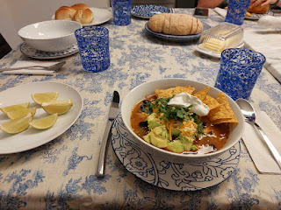

And then I had a comfortable bed to climb into at the end of a very long day.

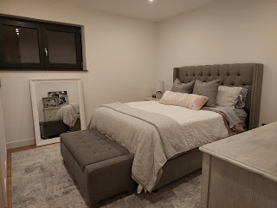

By the time the day was finished, I had a realization: Scott had picked me up at 10:00 a.m. to catch the shuttle at Del Din, and by the time I got to the Parker's house, it was after 8:30 p.m. I could have DRIVEN to their house faster than what it took to fly and then drive the additional 1.5 hours in the rental car!!

Maybe next time I

will

just drive. Then I can see the sights along the way and stop whenever I want to stop.

Tuesday, October 7th:

When I came upstairs to get some breakfast, I got my first peek at what their neighborhood looks like in daylight.

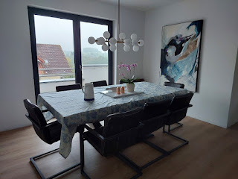

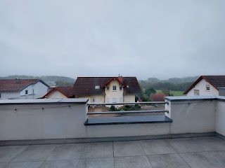

It was a lovely drive to get to Avery's house, which was only about 25 minutes south of where I was staying.

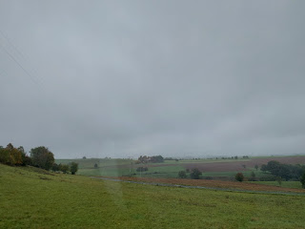

When she opened the door, you should have seen her face . . . she is such a doll. And so expressive.

She threw herself into my arms and clung to me for a really long time. XOXO

We hung out at their house for a while, playing with toys and chatting. I had asked Kylie ahead of time what she would like to do, and if she would maybe like to show me around the Ramstein Base, so that's what we did. I rode in their super nice BMW car for the 25-minute drive up to Ramstein.

One of the many beautiful trees in the parking lot . . .

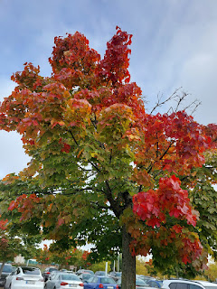

We went into the BX (Base Exchange), which - on such a massive base - was still surprisingly large. It felt like we had entered into a huge shopping mall! There was a big food court with several restaurants aimed to please all the U.S. civilians who are so far away from their favorite fast foods: Panda Express, Taco Bell, etc. Kylie and Avery got their lunch at Taco Bell, while I grabbed some honey walnut shrimp from Panda Express. The shrimp wasn't prepared exactly the same as what you would find in the U.S., though. The breading was slightly different, and the overall texture was interesting. I bet they have a basic recipe from Panda to follow, but they still have European standards to adhere to for the ingredients. (European standards are much higher than in the U.S. - in case you were wondering.)

I had fun taking selfies with Avery at our table while Kylie waited in line for their food to be prepared.

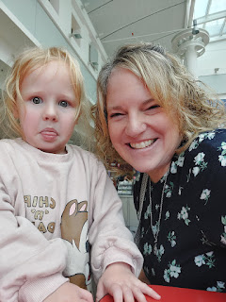

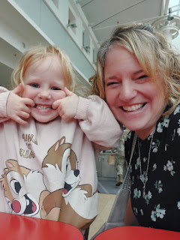

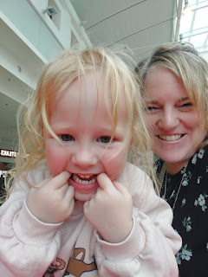

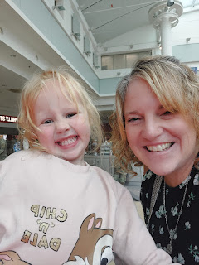

After we finished eating, we walked around the "mall" a little bit. There was a super cute German Christmas store that caught my eye, so we wandered in to take a look. Avery loved all of the stuffed animals, big and small, and she was fascinated with all the cuckoo clocks with so many intricate details carved into them.

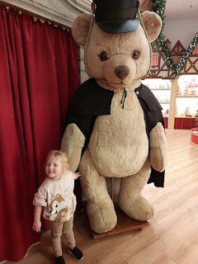

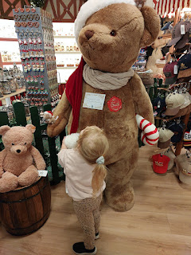

Video as we came into the tiny village of Knopp-Labach where they live: (12 seconds)

https://photos.app.goo.gl/JApHeSVu92c1WEuW9

Kylie had purchased a little Barbie coloring book and make-up set for Avery from the BX. Avery was so excited to open it up once we got home . . . and Kylie was so patient and sweet as she started applying layers of makeup to Avery's eyes and cheeks. Once she had been appropriately "decorated", I took her into the bathroom and lifted her up so she could see herself in the mirror. She was so delighted with the new look, ha ha. What a cutie!!

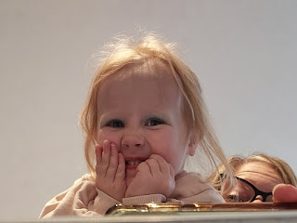

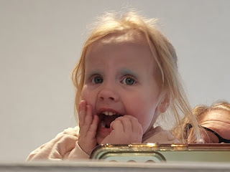

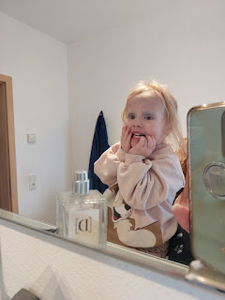

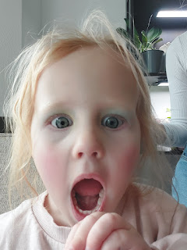

After we played with her Barbie book for a while, planting reusable stickers galore on all the Barbie faces, we went for a little walk. I had been wanting to check out the pumpkins at the end of their street, so off we went.

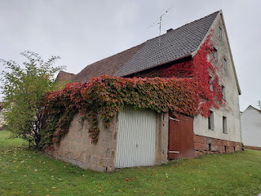

I'm not sure if these were all just part of an autumn display, or if they were available for purchase, but there was a wide assortment, and they were so festive and cute.

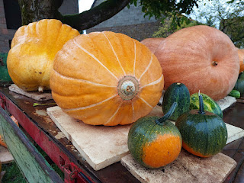

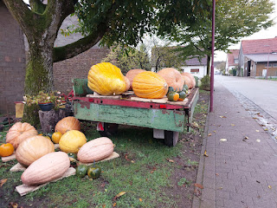

The homeowner had the cutest bench next to their front door, with the head of a cow carved out of wood.

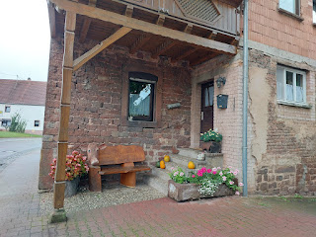

Next, we went to their favorite little German grocery store, just a few minutes away by car. It was pretty small, but they had a decent assortment of produce, meats, and pantry items. Germans also have several breads and sweet breads in their bakery sections . . .

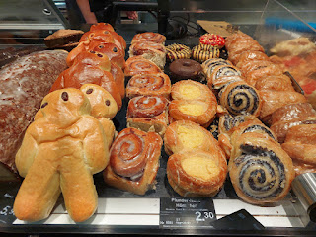

Packets of German spices

:

Top shelf L to R: Clove, Cucumber, Speculoos (Biscoff or similar to Pumpkin Pie Spice), Cardamom, Gingerbread spice.

Bottom shelf L to R: Smaller packet of Nelken (Cloves), Potash (a raising agent), Saurbraten spice (for a German sour pot roast/marinade - made up of ground mustard, coriander, dill seeds, allspice and cloves), and wild spice (for meat and game - made up of juniper, rosemary, oregano, pepper, mustard, and celery).

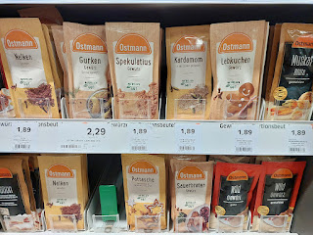

Have you ever seen so many wurst (sausages) in your life?

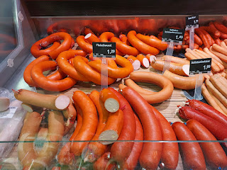

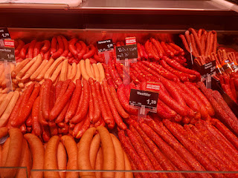

When it was time to leave, Avery somehow believed me that I would be back in a few days to see her again. Usually, she hates saying goodbye to anyone and turns into a blubbery mess. But this time, she did alright.

Wednesday, October 8th

: For the next several mornings, there was a beautiful and very dense fog that blanketed the area.

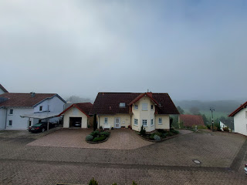

Video from the Parkers' balcony (with an "upstairs" side yard, including a grassy patch): (20 seconds)

https://photos.app.goo.gl/x2q1oqBJjQwf3uy27

After breakfast - and once the fog lifted somewhat - Marnie and I headed off for a couple of adventures. First, we drove up to a pumpkin patch near Darmstadt. The farm was called Bauer Lipp.

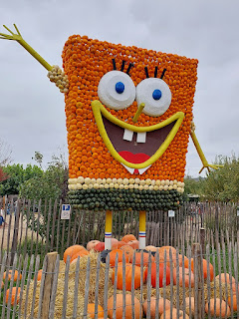

They had several areas for children and families, including a large grassy yard next to the parking lot with an assortment of ducks, geese, turkeys, chickens and baby chicks, etc.

Video of some ducks and geese eating out of a halved pumpkin: (7 seconds)

https://photos.app.goo.gl/QbDg94c35dXP4P7j7

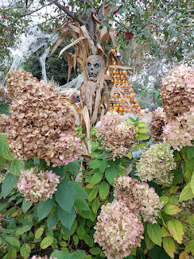

The farm was a mixture of Halloween decor and cutesy fall decor . . .

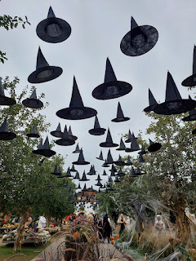

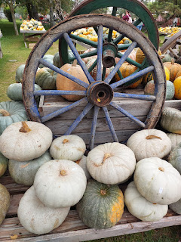

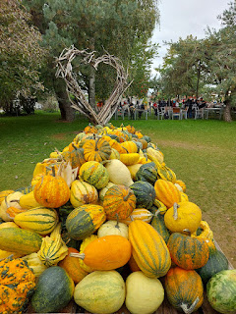

And they had some really clever animal sculptures that incorporated different colors of mini pumpkins and gourds . . .

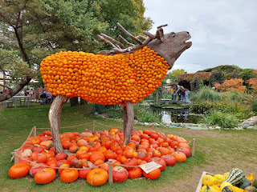

I'm not sure what these were, but they had a huge bin full of them . . . I loved their lime green color and their prickly-looking texture . . .

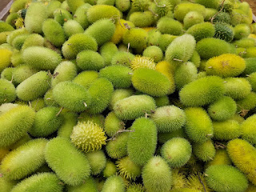

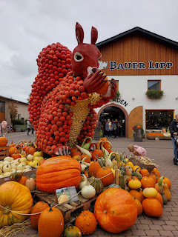

Guten Tag = Good Day

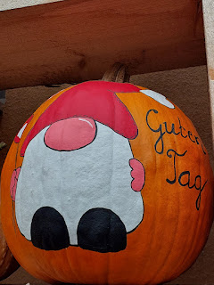

White asparagus - or Spargle, as the Germans call it - is so popular that they have Sparglefests every year in the spring . . . they taste a lot like green asparagus (maybe a little milder than the green), but they are grown in such a way that they never see the light of day. They are harvested in this "albino" state and are considered a delicacy - even in Italy.

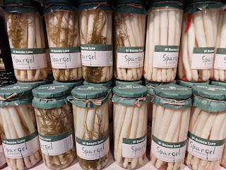

A few other products in the farm store included this raspberry syrup with basil . . .

(himbeer = raspberry)

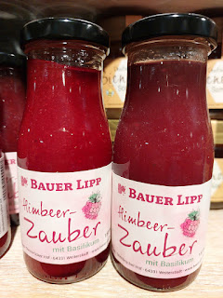

And colorful hard candies that are quintessentially German . . .

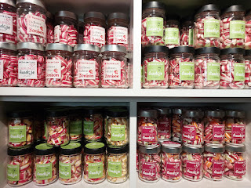

In the store, I bought some dried apples, a tiny little jar of creamed raspberry honey, and some chocolate/orange coated nuts.

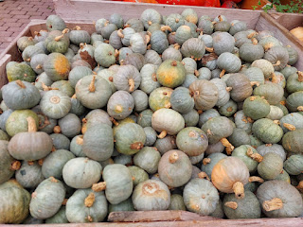

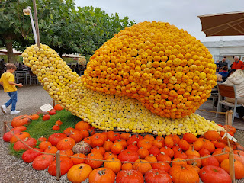

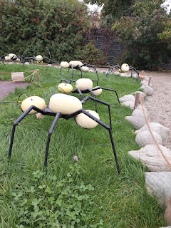

The farm also had a pumpkin carving area for families . . .

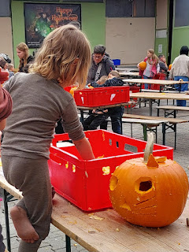

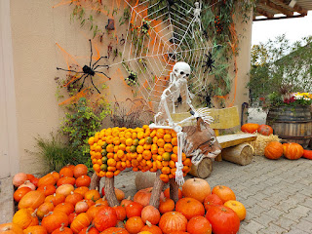

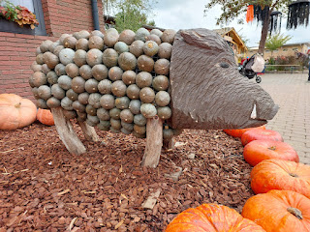

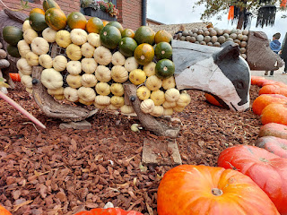

For lunch, Marnie and I shared a jar of butternut squash soup and a thin pizza of sorts called Flammkuchen. (flahm-kooken) The crust is a flatbread, but it's so thin that it reminded me of a tortilla. Both the flammkuchen and the soup were delicious.

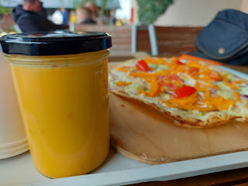

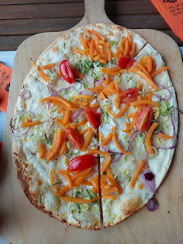

I really enjoyed seeing all of the different colors, speckles, and patterns on the heirloom pumpkins . . .

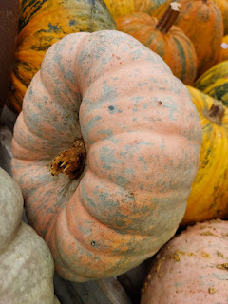

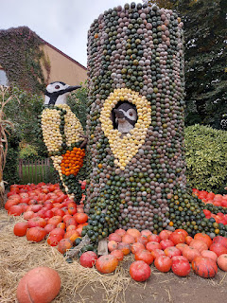

We spent a couple of hours at the farm before leaving. We could have stayed longer, but we had one more stop to make and we wanted enough time for that, too.

Google directed us from Bauer Lipp Farm to Ibersheim, and we obediently followed its directions until we reached a dead-end at the Rhine River. Google wanted us to get on the ferry boat and travel across the river to continue our journey, but we were extremely apprehensive. Neither of us had ever done anything like this before.

After some hemming and hawing and observing that the toll-collector was going from car to car to allow them to pay for the fee through their driver-side window, we figured that we could probably do it. Just as we were feeling brave enough to go ahead and try it, one of the two gates that closes off the access to the ferry started to close. Marnie squealed, "What do I do?!" I directed her to hurry and pull onto the boat. The far-left lane had several openings for us to pull in and park, so she did just that. The toll-collector came over to our car so we could pay him, and it cost 7.50 euros for the ride across to the other side of the Rhine. He was jovial and spoke really good English, so we felt a lot more at ease thanks to him.

Video as we drove toward the ferry: (5 seconds)

https://photos.app.goo.gl/XwLf2rFftidDTyb36

Video as we floated across the Rhine: (6 seconds)

https://photos.app.goo.gl/MN4W5sWBoNBntxTm6

Video as we drove off: (6 seconds)

https://photos.app.goo.gl/AL3YdDe7JK5i3PQC8

It was very organized as far as the order of disembarking. The far-right lane went first, then the middle lane of cars, then our far-left lane was the last to go. From there, it was only an 8-minute drive to Ibersheim. (Pronounced like ee-burz-hyme)

Ibersheim

is a very small town in the province of Worms (pronounced like "Vorms"). I would guess that the population is maybe 1,000 at the most. Back when my ancestors lived here in the late 1600's into the early 1700's, the Mennonite population was much more robust.

The Mennonites had endured a great deal of persecution back in Switzerland because of their religious beliefs. Many had been imprisoned, some had been attacked, and some had even been drowned in an attempt to punish or possibly eradicate them. The families were looking for a safer place to call home, and it was their lucky day over in Ibersheim, Germany.

The Elector, or Lord, of the Worms region needed farmers and other workers to update, replenish, and build up the farms and lands near Ibersheim. Things were in a serious decline due to the recent Thirty Years War. He didn't care what religion they were; he just needed a people who were willing to work hard. He was happy to let the Mennonites settle here because their reputation was very good - they were hard-working and respectful citizens. So, it became a win-win for everyone.

On my Dad's paternal line, our ancestors who came to Ibersheim included the Hockmans, Denlingers, Yoders, and possibly others.

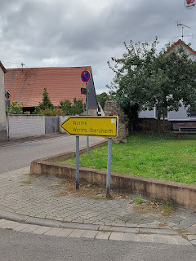

This sign indicates the jurisdictional area of Worms, but the town's name is below: Ibersheim. The word Stadtteil means "district".

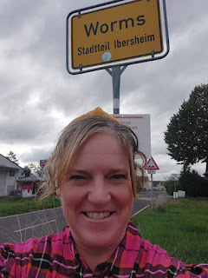

Video as we turned onto Kirchstrasse (or Church Street): (23 seconds)

https://photos.app.goo.gl/iEcLBPBv4SD7PDgW9

This is the Mennonite Church in Ibersheim. While what exists today was built in the early 1800's, this is still the exact site where the older Mennonite Church was built and where my ancestors would have attended.

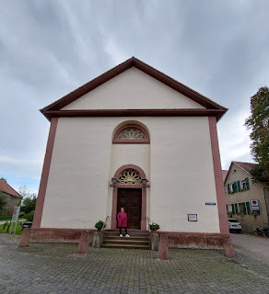

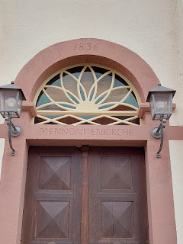

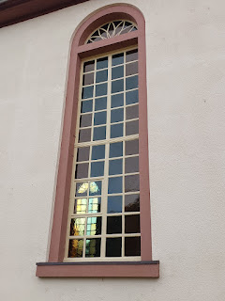

I had hoped to go inside, but the doors were locked. We asked a couple of passersby if they knew when it was open. One lady - who spoke very good English - told us that it's open on Thursdays and Sundays. So I made plans to return the following day . . .

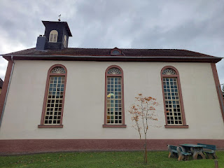

In researching the history of this building next to the church (shown below), I stumbled onto some interesting family history blogs that make mention of my ancestors, too. The building appears to be several homes all connected, with the words: Rohrhof (hof means farm), Stauffer, Kehr, Lang, Bergtholdt, and the years 1656 - 1975.

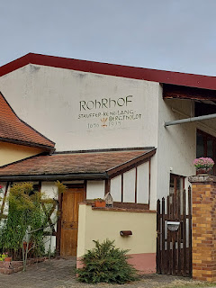

I think those words are referencing that the Stauffer family has been consistently living in this home since 1656, based on the dates and the blogs that I read through. There are some Stauffer descendants that still reside in the same home today - as recent as 2018.

Something interesting that I came across in one of the blogs was that some of our ancestors were named, along with where they had originally come from!

Link to the Daniel Haston Family Association Blog:

05 – Where Henrich Hiestand Was Born – Ibersheim, Germany – Daniel Haston Family Association

An excerpt from the blog above:

*Note: The 1664 Concession refers to the allowance/invitation for the Mennonites to come live in the Ibersheim area.

In 1683, nineteen years after the 1664 Concession, ten Mennonite men, who were heads of families in Ibersheim, were granted extraordinary rights not enjoyed elsewhere in the Palatinate.  They were granted rights to be “hereditary tenants.”  That meant they could pass on to their sons the tenant-rights they enjoyed for portions of the Ibersheim estate they were living on.

Konrad Hiestand

was one of the specially privileged ten.

Brubacher, Hans Jacob – from Hirzel, Horgen, in Canton Zürich

Dentlinger, Jacob – from Bernese Oberland (Highlands)

Forrer, Hans Jacob – from Hirzel, Horgen, Zürich

Gochenauer, Heinrich – from Fischenthal, Hinwil, Zürich

Hagmann, Ulrich – from Eidberg, Oberwinterthur, Zürich

Hiestand, Konrad – from Richterswil, Horgen, Zürich

Leitweiler, Hans – from Aarau, Aargau, and Zürich

Neff, Heinrich – from Vollenweid, Hausen, Zürich

Opmann, Peter – from Oberdiessbach, Bern-Mittelland

Reif, Heinrich – from Schönenberg, Horgen, Zürich

Hans Jacob Brubacher

is my 9th great grandfather. This was an absolute surprise to learn when I hopped onto FamilySearch to look at my Hockman ancestors. I hadn't really paid attention to anyone that far up on my Snider line before . . .

Surprise #1: I am related to the Brubachers, a name I was not familiar with previously.

Surprise #2: I am related to the Hiestand family - which is the whole premise of the family blog that I stumbled onto!! Konrad Hiestand (mentioned above) had a sister named

Klianna Hiestand

. Klianna married

Hans Jacob Brubacher

in 1658 in Switzerland. They moved to Ibersheim shortly before they gave birth to a son, Peter, in 1661. We descend from Klianna and Hans' daughter,

Maria Brubacher

(born 1665 in Ibersheim). She later married Hans Jacob Hagmann (mentioned below).

The

Jacob Dentlinger

mentioned (on the list of 10 men above) could be related to us. I do have a direct ancestor by the same name (nevermind the spelling differences - they tended to spell phonetically all those years ago). My 8th great grandfather

Jacob Dandliker

came from Hombrechtikon, Switzerland (in the Zurich canton) and moved to Ibersheim at some point. The dates almost match up perfectly, although my Jacob got married in Hombrechtikon the year

after

those 10 Mennonite men received the right to be hereditary tenants in Ibersheim. I doubt he was the same Jacob mentioned above, although they were likely related somehow.

Ulrich Hagmann

, also mentioned above, is my 9th great grandfather. He was born in 1634 in Eidberg, Switzerland, which doesn't show up on a map today. Essentially, it's a tiny hamlet outside of Winterthur, Switzerland and is NE of Zurich. He married

Maria Egli

in Switzerland in approx. 1660 and then moved to Ibersheim shortly thereafter. Their son, my 8th great grandfather,

Hans Jacob Hagmann

, was born in Ibersheim in 1663. Hans married Maria Brubacher (mentioned above).

Here is a link to another blog that I found regarding Ibersheim and its Mennonite history:

30 – Our Ancestors’ Little German Village of Refuge – Ibersheim – Daniel Haston Family Association

As I walked around with Marnie, I instantly recognized this house . . . I had already taken a photo of the same house back in 2021, and it's framed and hanging in my living room back in Idaho Falls. I just love it.

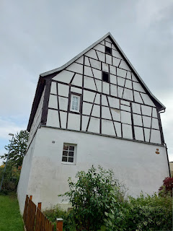

Marnie spotted this cute bicycle in the alley next to the church and said it would make a great photo . . .

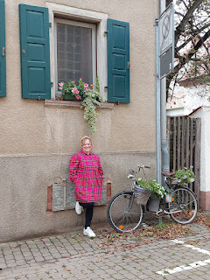

I wish I knew more about what these old painted symbols mean . . . we saw them on many of the old houses in Ibersheim . . .

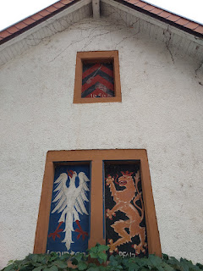

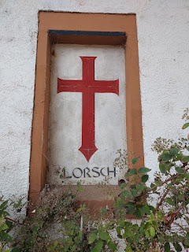

We saw what looked to be a poem printed on a plaque outside a gated property . . .

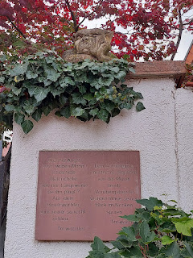

With Google Translate, the poem above says the following:

"Who's afraid of the wild man!

Is it deep melancholy or just boredom that plagues him?

No one can really make sense of the wall guard . . .

"He skeptically examines the newcomer from the wall.

Passers-by will feel his gaze on the back of their neck for a long time."

*The word "Torwachter" at the bottom = Gatekeeper

And interestingly - I have Tarwater ancestors, too. Their German surname looks like Thurwachter, which is very similar to "Torwachter". From what I have learned in years past, my Tarwater ancestors' profession was to stand guard in a TOWER that overlooked the Rhine River. They were toll collectors for any boats that were delivering goods up and down the river back in the 1600's.

Just an interesting coincidence there . . .

The architecture of this next house just oozes OLD. I was surprised to see it mentioned in another blog that shares some of the Stauffer family history as it pertains to Ibersheim.

Link is here:

Scribbler: Stauffer Family History

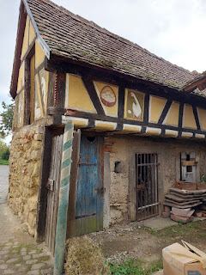

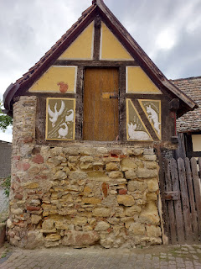

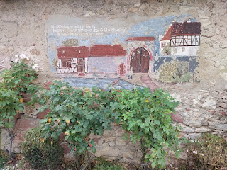

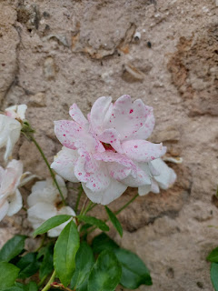

I took a peek inside the front window of this same house . . . I know, I know . . . I shouldn't be doing things like that. But the amount of construction in the back of the house led me to believe that maybe nobody is currently living there right now.

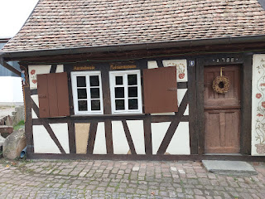

The main room inside the window looked like it could be an instruction room, or even a staged museum sort of room with how things might have looked a hundred years ago.

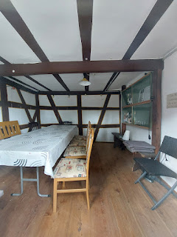

Menno Simons was born in the Netherlands in 1496. He was raised in the Catholic Church, but later rejected it and became entrenched in the Anabaptist faith by 1536. He was known for his diligence in studying the Word of God and acquiring personal revelation through prayer and scripture study. He influenced the Dutch Anabaptists to be less confrontational and more peaceful as a society.

The Mennonite Church was formed as he rose to leadership and taught a more peaceful existence than what the earlier Anabaptists were sometimes known for. He was opposed to infant baptism, and after a careful and lengthy study of the New Testament, "he was firmly convinced that only persons with a mature faith in Jesus Christ should qualify for baptism. He believed that the grace of Christ was sufficient for children until they reached the age of accountability and made a conscious choice either for or against Him. The experience of conversion was central to all of Menno's life and theology". (credit for these statements is from

https://www.britannica.com/biography/Menno-Simons

)

Simons was quoted as saying: (from Wikipedia)

"

For true evangelical faith is of such a nature that it cannot lie dormant; but manifests itself in all righteousness and works of love; it dies unto flesh and blood; destroys all forbidden lusts and desires; cordially seeks, serves and fears God; clothes the naked; feeds the hungry; consoles the afflicted; shelters the miserable; aids and consoles all the oppressed; returns good for evil; serves those that injure it; prays for those that persecute it; teaches, admonishes and reproves with the Word of the Lord; seeks that which is lost; binds up that which is wounded; heals that which is diseased and saves that which is sound. The persecution, suffering and anxiety which befalls it for the sake of the truth of the Lord, is to it a glorious joy and consolation."

— Menno Simons,

Why I Do Not Cease Teaching and Writing

, 1539

One street north of the Mennonite Church in Ibersheim is a street named after him . . .

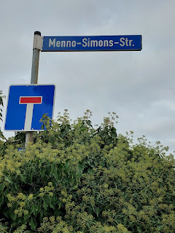

View from the end of Menno Simons Street, looking back on the town of Ibersheim . . . There is a paved walking path behind me that leads past some farm fields and probably has an offshoot that heads down to the Rhine River.

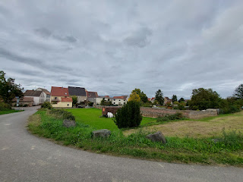

Another view of the same house from earlier . . . and something that I'm proud of is that I recently figured out how to erase unwanted objects in any photo I've taken on my phone. For example, in the fenced yard of this regal home, there is actually a giant green propane tank sitting there. I erased it to make a better photo. How about that?!

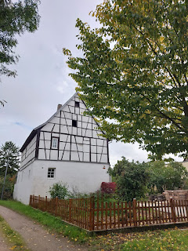

Here are a few additional photos as we walked around Ibersheim . . .

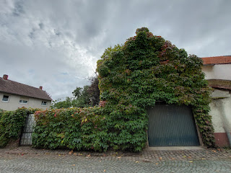

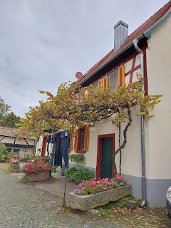

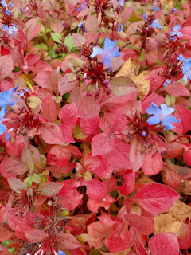

I used the camera on my Google Translate app to learn what the words meant underneath the cow and pig on the front facade of this house . . .

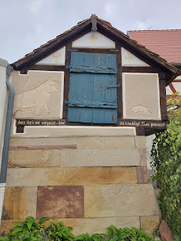

"Don't forget - - here . . . it was a noble pig."

I didn't recognize what this was (below) until Marnie explained that it's an insect nesting "house". Eww.

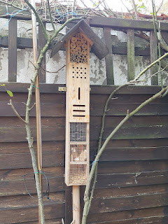

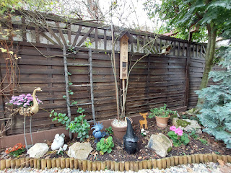

What used to be an old Mennonite barn has been converted into what appears to be apartments and homes now.

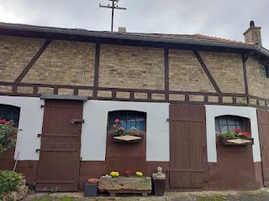

Kirchplatz = Church Square . . .

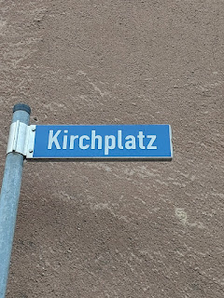

We had the best time exploring Ibersheim together. With all of the work that goes into moving to a new country, unpacking all the household goods and finding a place for everything, Marnie has had little to no time for exploring and adventuring lately. She told me that going with me to this cute little town woke up something inside her, and she can't wait to start venturing out from their little village and finding new and charming places around Germany with her family.

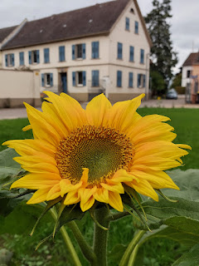

Oh - and I picked up a giant chestnut from the ground before we left Ibersheim. It feels very smooth and comforting in my hand . . .

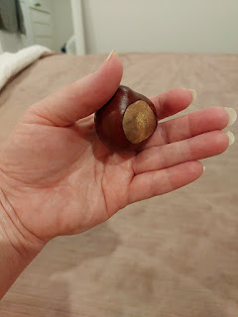

Thursday, October 9th:

Now that I knew about the NON-speed imit signs and what they meant, I decided to push the gas pedal a bit more. The highest speed I ever reached was 168 km/hr, but that was pretty brief. Mostly I hovered in the 155-158 zone. FYI: 168 km/hr = 104 mph. 155 km/hr = 96 mph. Tee hee.

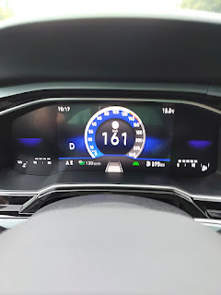

I drove back over to Ibersheim to see if the church was open . . . but it wasn't. Maybe it isn't open until the evening time?? I was all prepared with some information on Google Translate that I could share if I saw someone to talk to, but I never saw another human around the church.

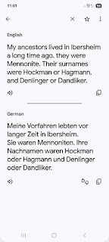

I took a photo of the history of the church on the sign next to the main doors. There is a screenshot below with an English translation - thanks to my handy dandy Google Translate app.

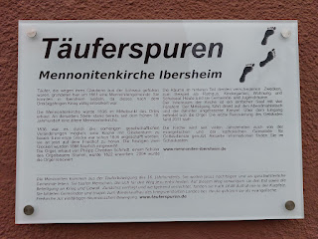

(click photo to enlarge and read) . . .

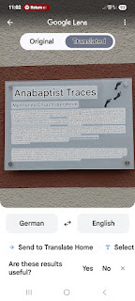

I looked on Google Maps to find a good access point (and parking) for the Rhine River, and I found a great spot just 5 minutes north of the Mennonite Church. The town is called Hamm am Rein, which just means Ham on the Rhine, ha ha. There was a small parking lot next to the river where I could park and go for a nice long walk.

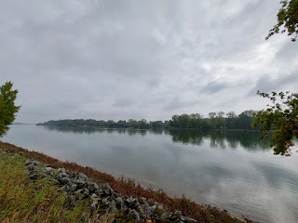

Video of the Rhine: (10 seconds)

https://photos.app.goo.gl/SWP7xVXKpg4RRjBq9

I hadn't walked very far from the car when I suddenly noticed how badly I needed to go potty. There was nothing in sight. In these tiny towns, you're lucky to find a simple pizzeria that's open in the middle of the day, and who knows if they even have a public restroom. So I walked back to the car and grabbed a couple of tissues that I had in my backpack and then made my way over to this tree. Nobody was on the path at all, thank goodness. There were some paved steps leading down to the river, so with the tree providing enough cover, I took care of business as quickly as possible and then I went off on my merry way. :)

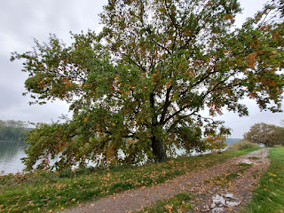

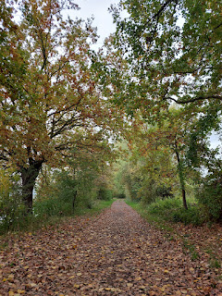

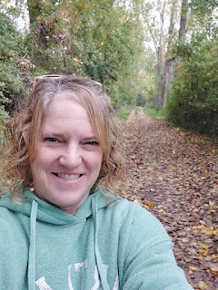

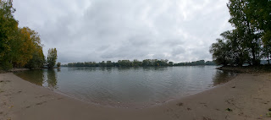

Video of a little sandy beach and access to the Rhine: (6 seconds)

https://photos.app.goo.gl/Vj2o8JCfJ3vPP2Cy9

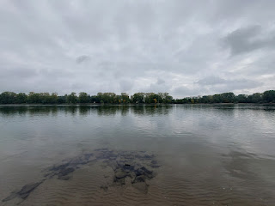

Video as I found the tiniest shell ever: (9 seconds)

https://photos.app.goo.gl/VbYA4o6MFweEvcE56

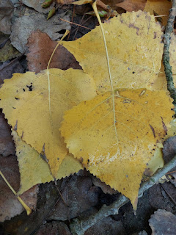

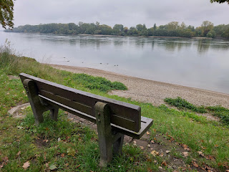

I brought home a few mementos from the Rhine . . .

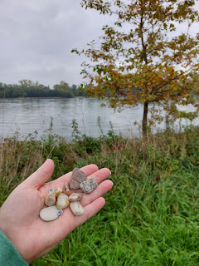

Video as I walked down a DIFFERENT set of steps going down to the river: (15 seconds)

https://photos.app.goo.gl/C33wDRnNHot72Tce7

Next stop: Framersheim, Germany

. This is another ancestral town where my Pittman/Bittman ancestors lived. My 5th great grandfather, Nicolaus Bittmann was born here in 1727. His father, Andreas Bittmann was born here in 1701, and the list goes on.

I stopped once on the side of the road between Ibersheim and Framersheim because the vineyards and the countryside were too beautiful to just fly on by without taking any photos.

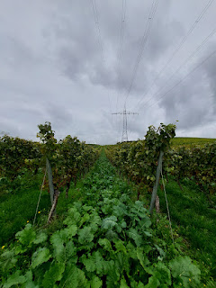

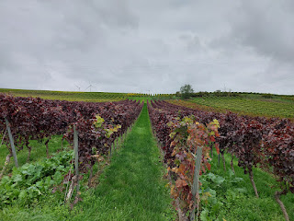

Getting closer . . .

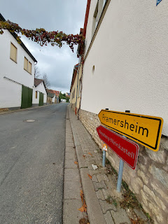

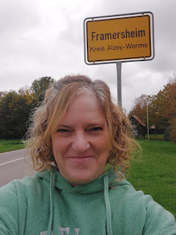

Video as I came into town: (44 seconds)

https://photos.app.goo.gl/cmhFeSgJzgFNrTqH8

One thing I noticed as I visited Framersheim that day was that there was a mixture of old and new architecture. Some streets were lined with older homes, and other streets had houses that were very modern and handsome. I even saw a neighborhood with fancy cars (like a Porsche) parked in some of the driveways near the cemetery.

Once I found a parking place, I realized that I needed to go to the bathroom again, plus I was hungry, ha ha. Most of the restaurants nearby either weren't open until dinnertime, or they were just about to close for the afternoon. I had to expand my search and then drive over to a nearby (and larger) town with more amenities. I ended up at a small shopping mall in Alzey with a Thai restaurant inside. They had the BEST Coconut Chicken Soup I've ever had. They also had a bathroom. :)

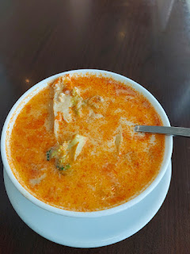

Video of the bakery items next door to the Thai restaurant: (8 seconds) *I bought a strudel for later.

https://photos.app.goo.gl/LXXYShU3DcWehnRi8

I drove back over to Framersheim (only about 6-7 minutes away) and found the exact same parking place as before. I was very close to the Katholische Kirche St. Martin, but I needed to visit the OTHER church down the street.

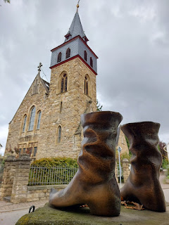

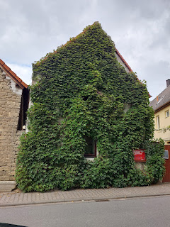

In front of the Jakobuskirche Evangelische Jakobusgemeinde (Evangelical St. James Parish), there is a monument and memorial for those who lost their lives during the two World Wars. I noticed that there were some Bittmanns on the list.

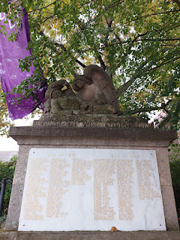

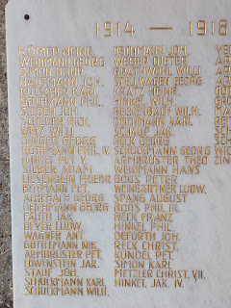

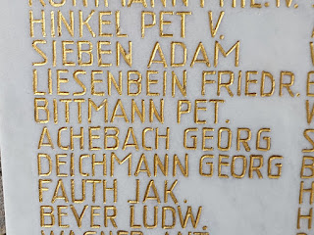

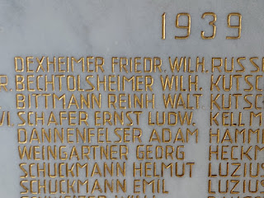

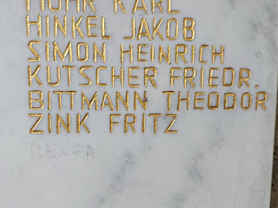

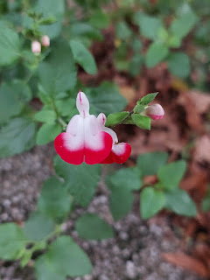

Once the Bittmanns (or Pittmans) arrived in the U.S. in 1749, they settled in Strasburg, VA and attended the St. Paul's Lutheran Church. Because they attended a Lutheran Church in the U.S., the assumption is that they would have also attended a Lutheran Church back in Germany.

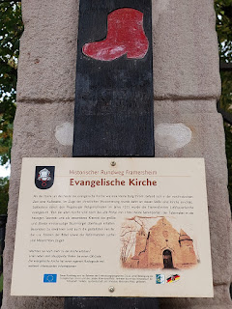

The English translation states that this Protestant Church today was built on top of an older Protestant Church that stood as early as 1555. FYI: The Protestant faith includes Lutherans, Methodists, Baptists, and Presbyterians. There is a side door still in use now - one that is dated 1749. The sign also professes that the church has the oldest and largest single-manual silent organ in existence, although the internet would disagree (because I looked). This type of organ only has one keyboard, meant to be played silently or quietly. The "silent" part means that there is a headphone jack for the organist to practice privately without disturbing others.

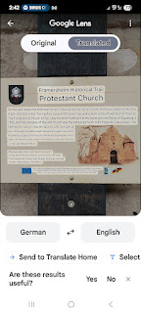

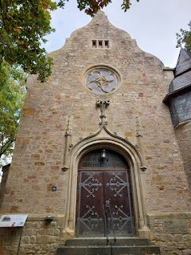

Very convenient to my self-guided tour was that I arrived at the church at the same time as this gentleman . . .

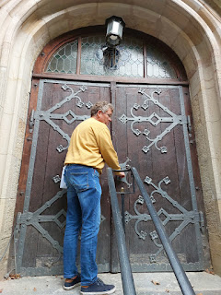

Turns out his name is Kurt and he is the pastor of this congregation. He offered to let me inside and then walked over to the left side of the building to retrieve a key to the front door.

Video of the interior: (11 seconds)

https://photos.app.goo.gl/yFYarBVyxRKXWNfv5

He explained that the church has been receiving extensive renovations over the past few years, including updates to the roof, and this year workers have been updating the interior. While the work continues, the congregation has been meeting down the street at the Catholic Church, sharing the building with them for a while.

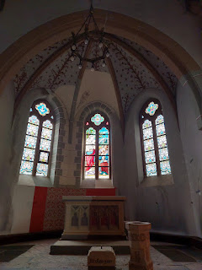

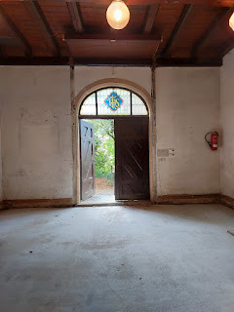

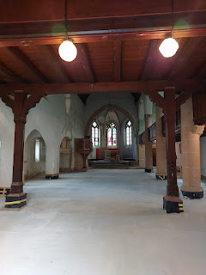

Side view of the church . . .

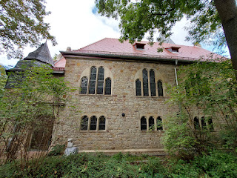

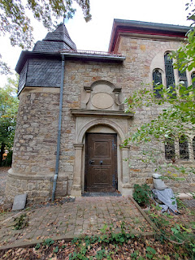

The reason why I chose to come here is because my ancestors lived in Framersheim for around 100 years, according to the records that are available. From what I can see on FamilySearch, they were here as early as the late 1600's and some of their descendants were born as late as 1744 in Framersheim before some of them immigrated to the U.S. a short time later.

This side door, shown both above and below, has the date of 1749 inscribed over it. In my mind's eye, I can just imagine all of the family events that could have taken place here . . . regular church attendance, christenings and baptisms, weddings, funerals, community gatherings, Christmas celebrations, etc.

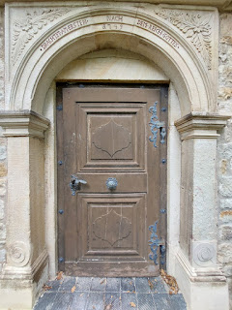

Kurt pointed out to me that there have been some very old headstones discovered from time to time in the gardens that surround the church. As the dirt settles after a rainstorm, and as the gardeners pull weeds, etc. a headstone sometimes begins to surface. I could not get any closer to see what information might be on them, but you can kind of see one of the white headstones leaning up against the fence through all the weeds in the photo below.

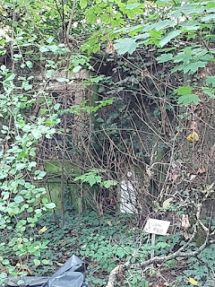

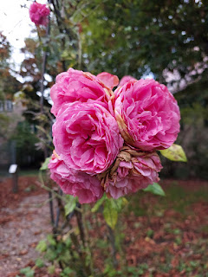

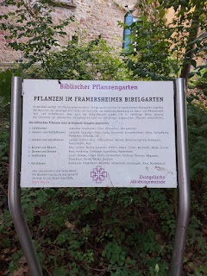

I couldn't get the translated version to load in the correct spot, dang it. So I will just tell you what the above sign says:

Biblical Plant Garden - Plants in the Framersheim Bible Garden.

110 plant species are mentioned in the Bible - some of which are planted here in the Framersheim Bible Garden. People of that time often had a much more intense relationship with the natural and plant world. Medicinal and aromatic plants, as well as cultivated plants, were often used in a variety of ways. We would like to illustrate the beauty of plant creation with a few selected plants.

The biblical plants are divided into the following groups:

1. Field Flowers: Anemone, cornflowers, lilies, daisies, mullein.

2. Spice and Aromatic Plants: Lavender, oreganum (hyssop), rue, horsemint, black cumin, mallow, curry plant, madder root, coriander, dill.

3. Spice and Medicinal Plants: Bay, castor oil plant, olive, St. John's wort, wormwood, Roman chamomile, garlic, poppies, aloe.

4. Bushes and Trees: Ivy, laurel, myrrh, cypresses, pines, cedars, oaks, juniper, willow, broom.

5. Thorns and Thistles: Rose, Christ thorn, globe thistle, milk thistle.

6. Field Crops: Leek, onion, lentils, flax, chickpeas, pumpkins, melons, chicory, henbane, barley, wheat, sorghum.

7. Fruit Trees: Apple tree, fig tree, yarrow, date palm, pomegranate, olive, almond tree.

"Lord, how many are your works! In wisdom you made them all. The earth is full of your creatures."

~ Psalm 104:24

~ Evangelical St. James's Church

I didn't take a photo of the garden areas because unfortunately, they were a little unkempt . . . maybe because during the construction, people haven't been taking as good care of the landscaping as they might otherwise do.

But what a clever thing to do - to have a garden with plants that are mentioned in the Bible!!

The next place I walked to was the cemetery down the street, known as the Framersheim Friedhof. Friedhof means cemetery. It is pronounced like Freed-hoff. If there are ever two vowels together in a German word, they pronounce the second one. ie = ee / ei = long "i" sound. ((Like Ibersheim = HYME at the end.)

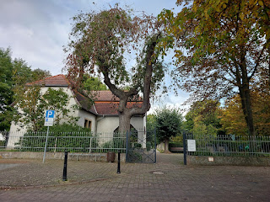

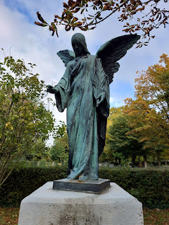

The cemetery was substantial in size, but laid out really well. There were paved walkways to navigate in between all the rows and I didn't have to walk on any sparse, muddy grass - which I've done on occasion elsewhere. In many places in this cemetery, I could walk closer to the headstones on well-groomed pea-gravel paths.

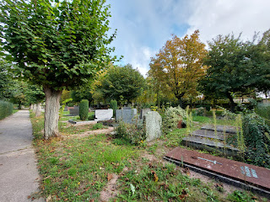

I was hunting for Bittmann names on the headstones, but I found a few Schneiders as well. I've been told that the surname Schneider in Germany is equal to the surname Smith in the U.S. However, with God on my side, I will not be deterred. Where there's a will, there's a way - - and I WILL find the origins of my Snider family someday!!

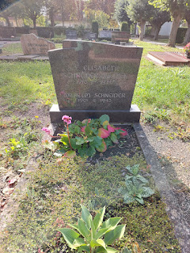

While this isn't a family plot, I did like the tidy and well-cared for plantings . . .

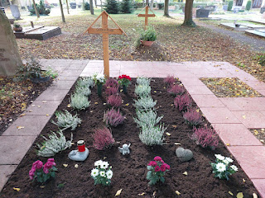

Feel free to scroll past all the headstones if you'd rather skip them . . .

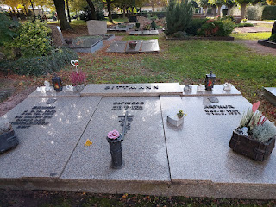

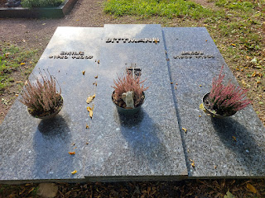

Again, I loved the design of the plants and rocks for this next one . . .

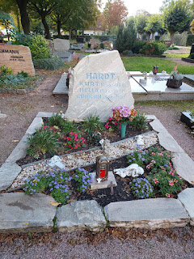

Another Schneider headstone . . .

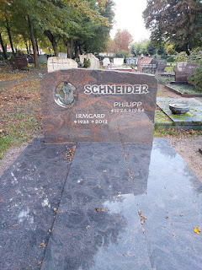

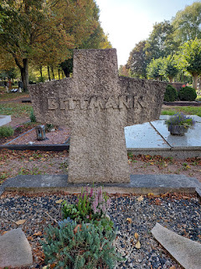

Another Schneider family . . .

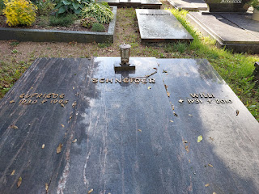

Bittmann . . .

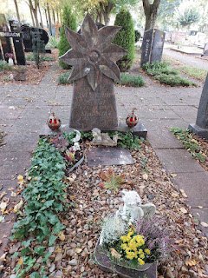

According to this next headstone, Elisabeth Bittman is still living at 91 years old . . .

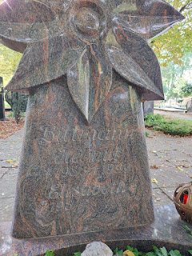

Once again, a beautiful floral arrangement . . . but no relation . . .

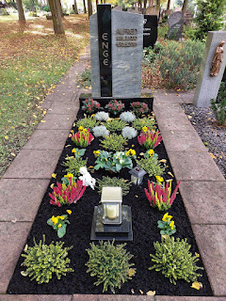

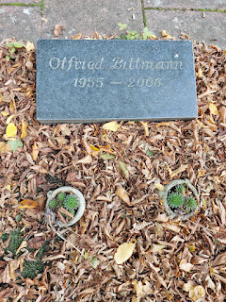

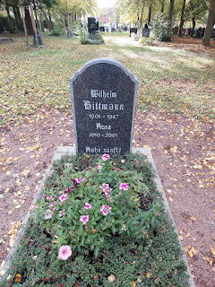

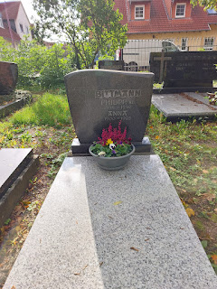

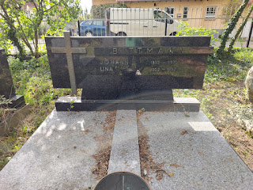

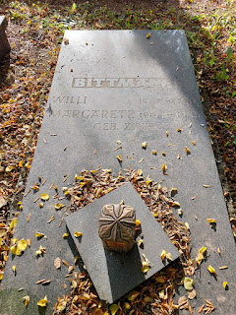

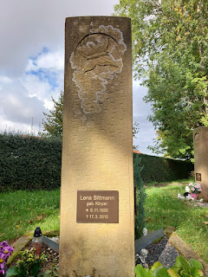

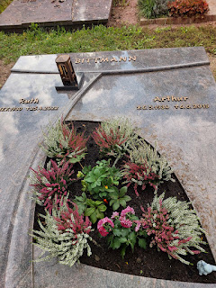

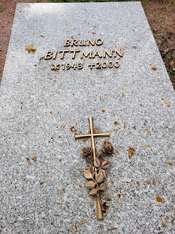

There is an adjacent section of the cemetery, known as the Jewish Cemetery (Friedhof).

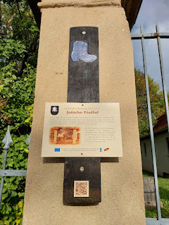

This translation explains the previous sign for the Jewish section . . .

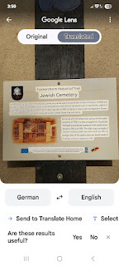

And that concludes my visit to the Friedhof in Framersheim. It was a beautiful cemetery. Its peaceful nature reminded me of the Ukiah CA Cemetery, with all the trees and the overall sense of quiet and serenity.

Friedhofsweg means Cemetery Path . . .

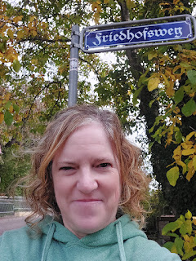

This was the neighborhood that I mentioned earlier, that had a great mix of old + new. Some of the homes were clearly old on the outside, but based on how clean-cut they each looked, I bet they were extensively updated on the inside, too.

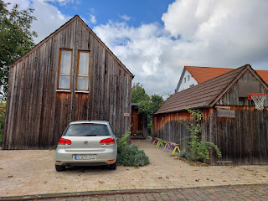

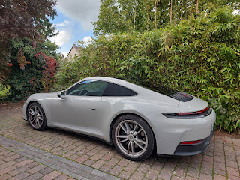

I made my way back to where I parked next to the Catholic Church . . .

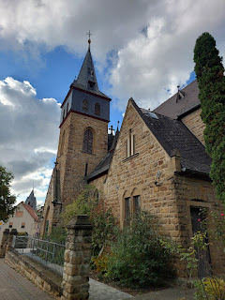

And I took a nice break to eat my strudel and chug some water . . .

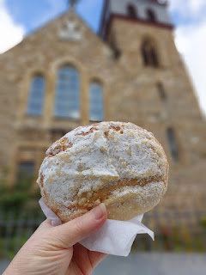

Before heading up into the hills above Framersheim to see one last thing . . .

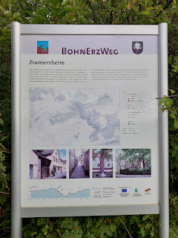

Framersheim has something unique up there - a circular labrynth of sorts that several of the locals contributed to. They wanted to make an artistic statement that even though the hills now have several gargantuan windmills, life is still meant to be beautiful and artsy and simple. (Confession: I actually really like seeing windmills and I don't mind their size.)

I parked next to this map and explanation about Framersheim, a town that has been here since 769.

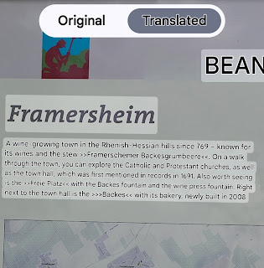

The second portion of the translation talks about a couple of festivals that they have locally each year.

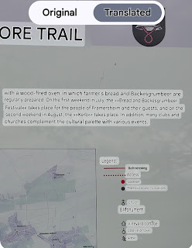

I was grateful that the day was not overcast or rainy. The sunny skies and cloud formations made the views of Framersheim even more spectacular from the hills above . . .

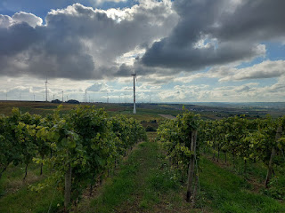

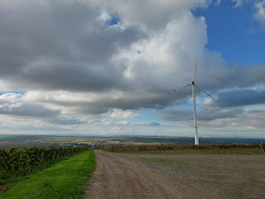

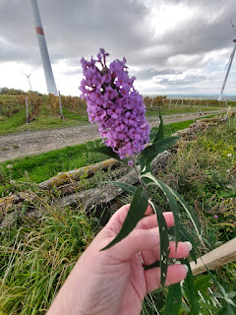

Walking down a short dirt path from where I parked, I found the labrynth.

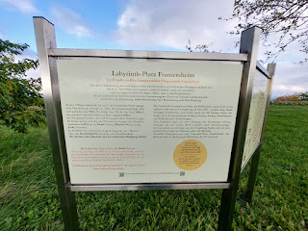

Here is the explanation for the labrynth - in their own words . . .

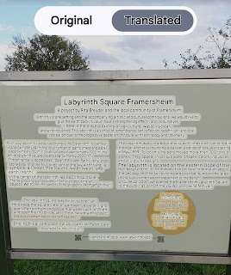

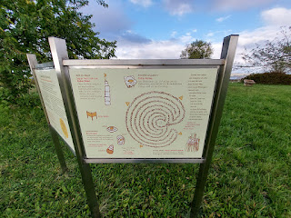

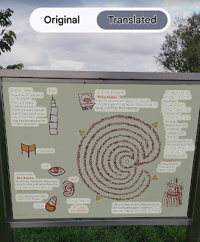

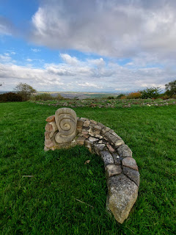

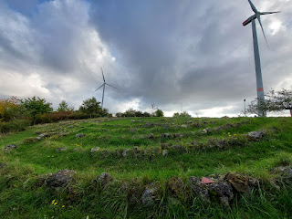

One of the 4 triangular mosaic stones to represent air, fire, water, and earth . . .

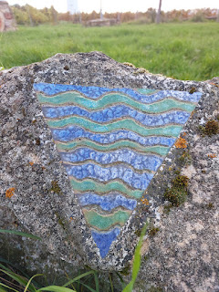

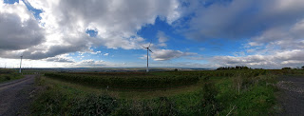

There were a few bunches of grapes that had not been harvested and were starting to turn into raisins. I'm not sure why they were left behind . . .

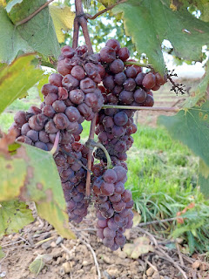

It was a magnificent few days of exploring, spending time with Avery, my friend Marnie, and seeing some ancestral towns that belonged to my people so long ago. I can't wait to go back and explore these areas further!

In the next blog post, I'll share the events of the final two days in Germany before heading back to Italy.

As I mentioned earlier, there's been a lot going on this month! A trip to Germany, a trip to Portland, Oregon, a trip to Rome (this coming week Monday - Thursday), and then the whole month is gone!! Wow.

Happy Halloween to all of you trick or treaters and hooligans out there. Be safe. And brush your teeth.